# Non-teaching Staff Perception Study

# **Growth Opportunities**

## Over-all environment in college

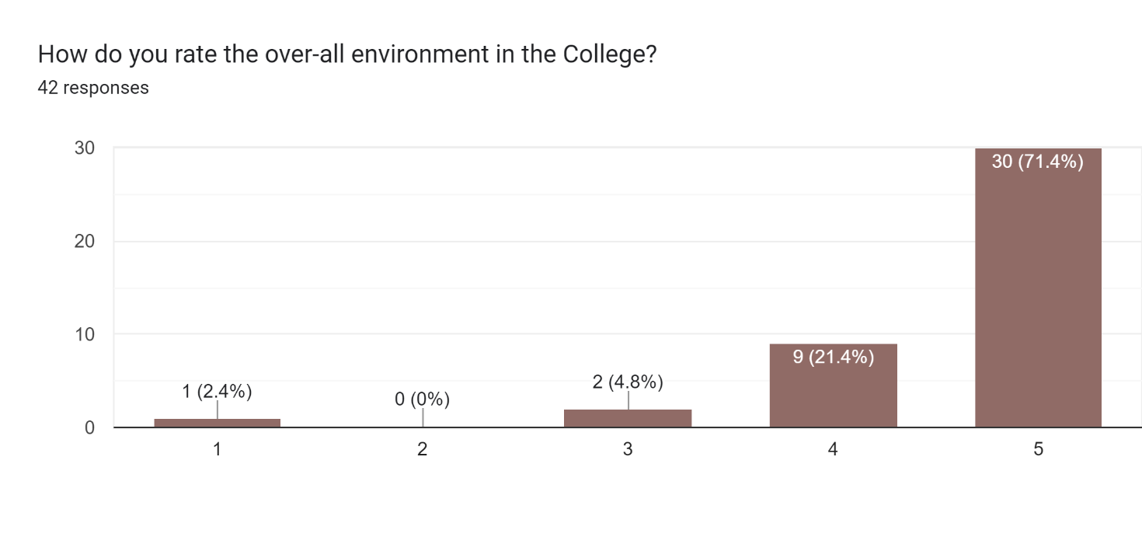

Mean: 4.59, Median=5

Nearly 71.4% of the respondents have given highest ranking to the overall environment in the college, 5. Most of the respondents perceive the ranking above 4.

## Adequacy of growth opportunity

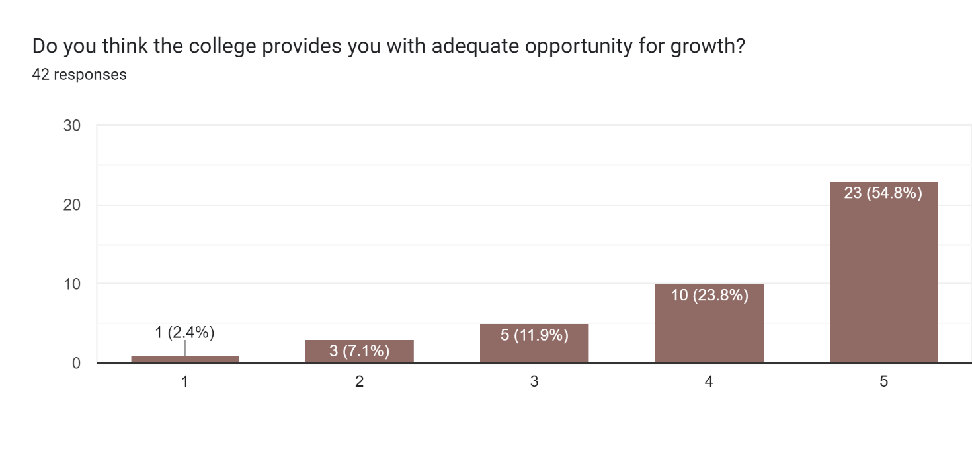

Mean = 4.21, Median =5

Nearly 55% of the respondents have given highest ranking to the adequacy in opportunity for growth, 5. Most of the respondents have ranked it above 4.

## Skill enhancement course

## 

81% of the respondents have agreed that the college organise skill enhancement courses for its support staff.

# **Availability of Infrastructure/facilities**

## IT infrastructure

## 

Not Answered =1, Mean =4.19. Median=5

Most respondents perceive that the IT infrastructure in the college can be ranked on the higher end, more than 4.19.

## Canteen facility Not Answered: 1, Mean = 4, Median=4

The distribution of the respondents in terms of their ranking is symmetrical, given mean is equal to the median of their ranking. Nearly 76% of the respondents have raked the canteen facility either 4 or 5.

## Primary medical facility

## 

## Not Answered=1, Mean=3.95, Median=4

Primary medical facility in the college are perceived to be ranked at 4 or 5 by nearly 74% of the respondents. Most respondents are with ranking more than mean ranking, 3.95.

## 4. Banking facility

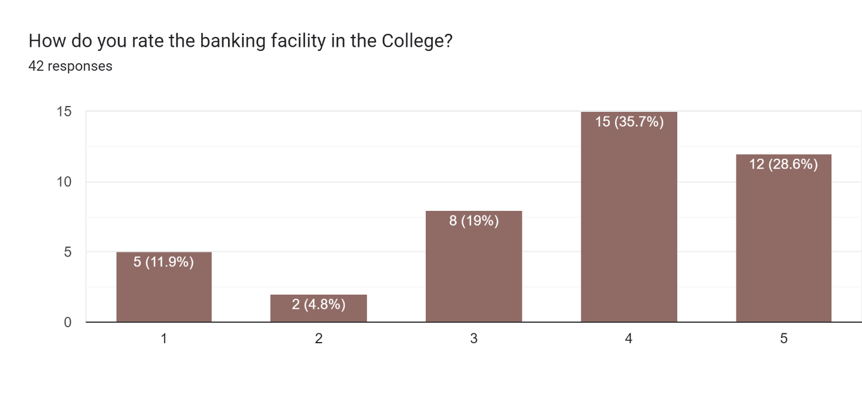

Not Answered =5, Mean=3.64, Median=4

Banking facility in the college are perceived to be ranked at 4 or 5 by nearly 65% of the respondents. Most respondents are with ranking more than mean ranking, 3.64.

## Timely disbursal of salary

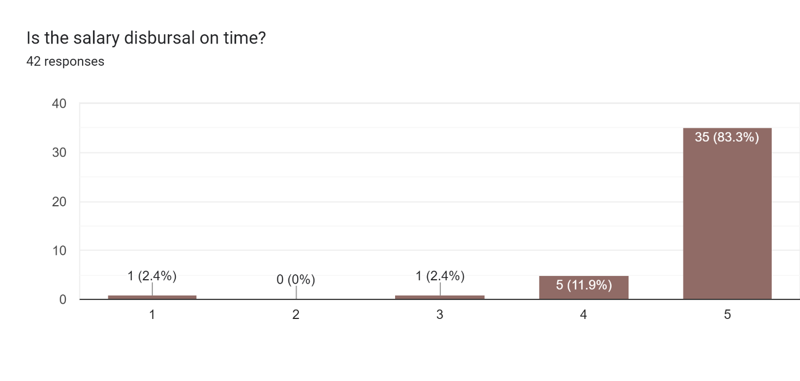Mean=4.73, Median=5

More than 83% of the respondents perceive that their salaries on time, with highest ranking 5. Most respondents are with ranking more than mean ranking, 4.73.

## Promptness in processing of allowance requests

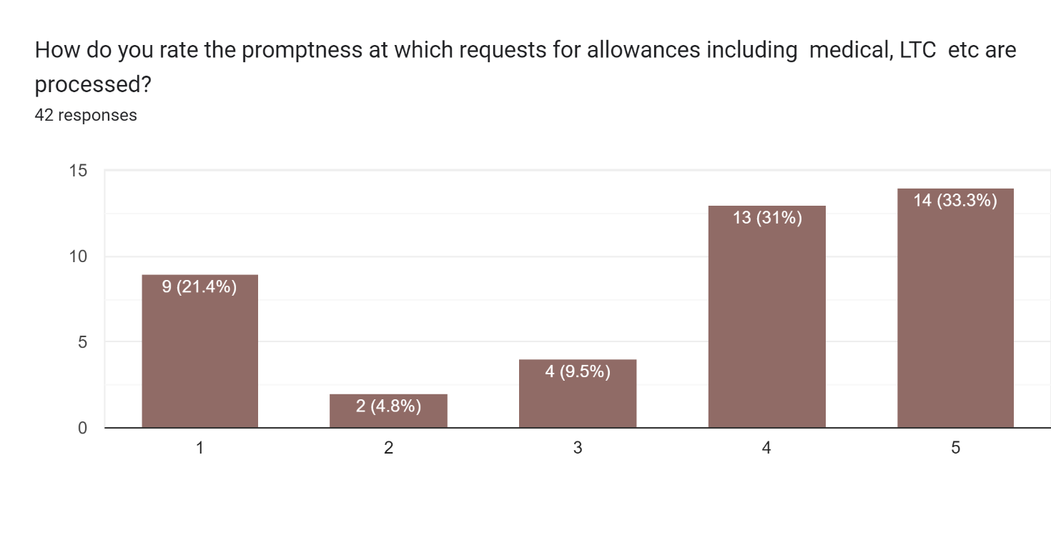

Mean=3.5. Median=4

While nearly 64% of respondents have ranked it at the higher end, 4 or 5, there are 21.4% respondents who have perceived that the system of processing of allowance request must get lowest ranking (1). Most respondents are with ranking more than mean ranking, 3.5.